**Shipping Application**

**Documentation**

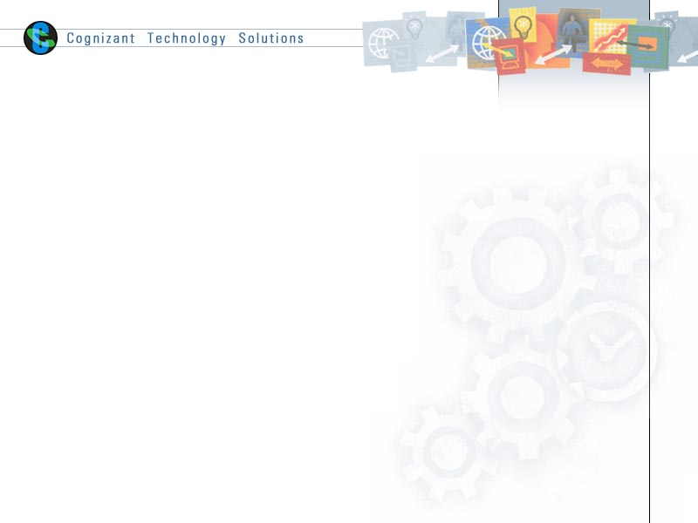

|  |  |  |  |
| --- | --- | --- | --- |
|  | **Prepared By** | **Reviewed by** | **Approved By** |
| **Name** | Rahul Rana  Naveen Kumar Singh Vishal Singh Rawat |  |  |
| **Role** | - |  |  |
| **Signature** | - |  |  |
| **Date** | 08/05/2019 |  |  |

Contents

1 Introduction 3

1.1 About this document 3

**1.1.1 Purpose & Scope of the document 3**

**1.1.2 Intended Audience 3**

1.2 About the Project 3

**1.2.1 Scope of the system 3**

**1.2.2 System Perspective 3**

**1.2.3 Architecture diagram 4**

**1.2.4 Impact of the System 4**

2 Software Requirements 5

2.1 Angular 5

2.2 Visual Studio Code 5

2.3 Python 5

2.4 MongoDB 6

3 Installations 6

3.1 Angular 6

3.2 Python 7

3.3 MongoDB 11

4 Project Requirements 19

4.1 Packages in Angular 19

4.2 Packages in Python 22

5 Practical Implementation 23

6 Annexure 34

7 Terms & Conditions 34

8 Change Log 35

# Introduction

## About this document

### Purpose & Scope of the document

The purpose of the document is to create a shipping based web application that will have login with captcha and signup page for user and will store the data of all the items sent for shipping. Each item should have its unique id and barcode associated with it.

The scope of this document to create a web application that will generate bar code every item an item is added with the permission of admin.

### Intended Audience

Project Team

## About the Project

The objective of the project is to create a web application that will be user friendly and will have different interfaces for admin and user. Admin should have various privileges like remove a user add another admin accept or reject a shipment.

The following are the various interfaces in the application

1. User Interface
2. Admin Interface

### Scope of the system

* **User:** User will have various options like can add item view his profile can check the orders that has been made by the user and various details related to user. User have to wait until the shipment is accepted by the admin.
* **Admin:** Admin will get all the options like which items should be accepted for the shipment if accepted a bar code will be generated associated with the particular shipment.

### System Perspective

This application will provide a user-friendly option for shipment process. By generating a unique order id and barcode associated with each shipment. Contact number of user and admin will be used as their unique id.

### Architecture diagram

Login

DATABASE

Server

(Restful Service)

Validation

False Data Fetch

Request

True Response

Type =Admin Type=User

UserHome

AdminHome

Profile

Add Item

Orders

Orders

Add admin

Profile

Contact

Delete User

Order Detail

### Impact of the System

The web application is responsible for storing and generating barcode for shipment details

And provide user-friendly interface for management of shipment. Application will generate unique order id to each shipment and admin will be able to accept or reject shipment.

# Software Requirements

* Angular(Frontend)
* Visual Studio Code (Text Editor)
* Python(Backend)
* MongoDB(Database)

## Angular

Angular is a JavaScript framework for building web applications and apps in JavaScript, html, and Typescript, which is a superset of JavaScript. Angular provides built-in features for animation, http service, and materials which in turn has features such as auto-complete, navigation, toolbar, menus, etc. The code is written in Typescript, which compiles to JavaScript and displays the same in the browser. In this application Angular is used for frontend.

There are three major releases of Angular. The first version that was released is Angular1, which is also called AngularJS. Angular1 was followed by Angular2, which came in with a lot of changes when compared to Angular1.

## Visual Studio Code

Visual Studio Code is a source code editor that can be used with a variety of programming languages. Instead of a project system it allows users to open one or more directories, which can then be saved in workspaces for future reuse. This allows it to operate as a [language-agnostic](https://en.wikipedia.org/wiki/Language-agnostic) code editor for any language, contrary to [Microsoft Visual Studio](https://en.wikipedia.org/wiki/Microsoft_Visual_Studio) which uses the proprietary .sln solution file and project-specific project files. It supports a number of programming languages and a set of features that differs per language. Unwanted files and folders can be excluded from the project tree via the settings. Many of Visual Studio Code features are not exposed through menus or the user interface, but can be accessed via the command palette

## Python

Python is an interpreted, high-level, general-purpose programming language. Created by Guido van Rossum and first released in 1991, Python has a design philosophy that emphasizes code readability, notably using significant whitespace. It provides constructs that enable clear programming on both small and large scales. We will use python for backend to create our server.

## MongoDB

MongoDB is a document-oriented NoSQL database used for high volume data storage. MongoDB is a database which came into light around the mid-2000s. It falls under the category of a NoSQL database. MongoDB stores data in JSON-like documents, which makes the database very flexible and scalable. We will MongoDB database for storing admin, user and order details.

# Installations

## Angular

1. Open your browser and navigate to: <https://nodejs.org/en/>  than Download the current version of Node JS.

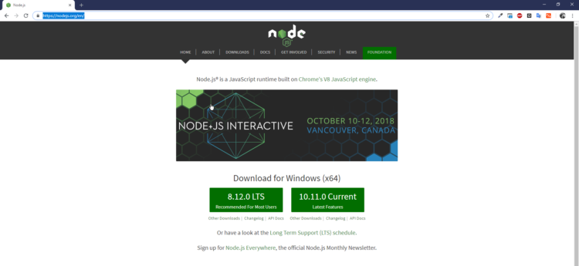

1. Install Angular

Angular CLI is a command line interface for Angular. To install the Angular CLI;

Open your command prompt, and type “**npm install -g @angular/cli**”

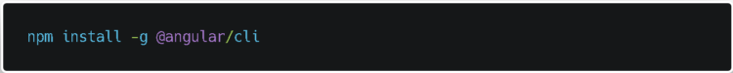

1. Create a workspace and initial application.

**ng new awesome-project**

## Python

The Python download requires about 25 Mb of disk space. Keep it on your machine, in case you need to re-install Python. When installed, Python requires about an additional 90 Mb of disk space.

* Downloading

1. Click [Python Download](https://www.python.org/downloads/) to open the download link in your browser.

The following page will appear in your browser.

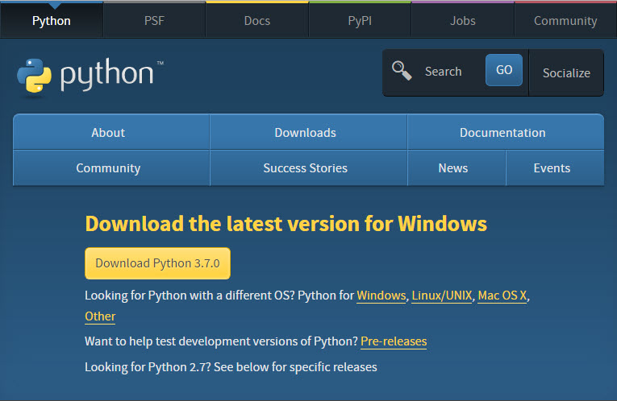

1. Click the **Download Python 3.7.0** button.

The file named **python-3.7.0.exe** should start downloading into your standard download folder. This file is about 30 Mb so it might take a while to download fully if you are on a slow internet connection The file should appear as below image.



1. Move this file to a more permanent location, so that you can install Python (and reinstall it easily later, if necessary).
2. Feel free to explore this webpage further; if you want to just continue the installation, you can terminate the tab browsing this webpage.
3. Start the Installing instructions directly below.
4. Double-click the icon labeling the file python-3.7.0.exe.

An Open File - Security Warning pop-up window will appear.

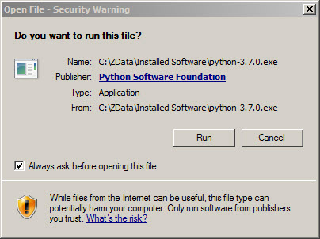

1. Click **Run**.

A **Python 3.7.0 (32-bit) Setup** pop-up window will appear.

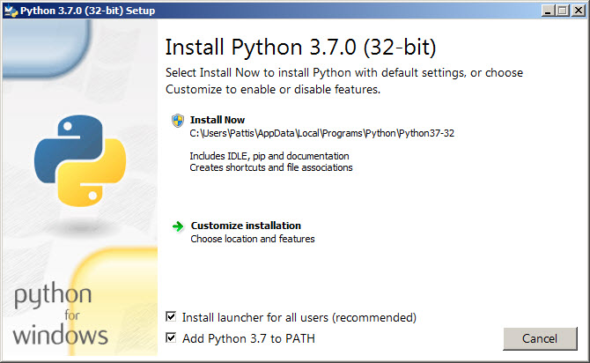

Ensure that the Install launcher for all users (recommended) and the Add Python 3.7 to PATH checkboxes at the bottom are checked.

If the Python Installer finds an earlier version of Python installed on your computer, the Install Now message may instead appear as Upgrade Now (and the checkboxes will not appear).

1. Highlight the Install Now (or Upgrade Now) message, and then click it.

A User Account Control pop-up window will appear

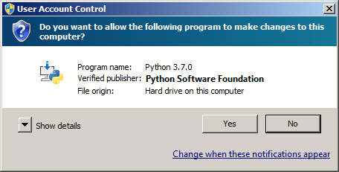

1. Click the Yes button.

A new Python 3.7.0 (32-bit) Setup pop-up window will appear with a Setup Progress message and a progress bar.

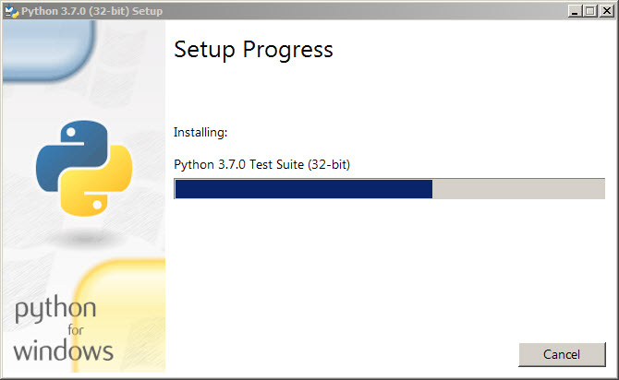

During installation, it will show the various components it is installing and move the progress bar towards completion. Soon, a new Python 3.7.0 (32-bit) Setup pop-up window will appear with a Setup was successfully message.

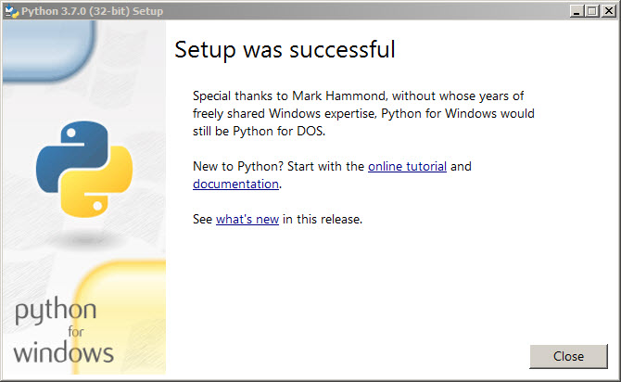

1. Click the Close button.

Python should now be installed.

To try to verify installation,

1. Navigate to the directory **“C:\Users\XYZ\AppData\Python\Python37-32**
2. Double-click the icon/file python.exe.

The following pop-up window will appear.

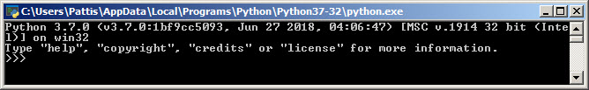

A pop-up window with the title C:\Users\XYZ\AppData\Python\Python37-32 appears, and inside the window. on the first line is the text Python 3.7.0 ... (notice that it should also say 32 bit). Inside the window, at the bottom left, is the prompt >>>: type exit () to this prompt and press enter to terminate Python.

## MongoDB

### Step 1 — Download the MongoDB MSI Installer Package

Head over [here](https://www.mongodb.com/download-center/community) and download the current version of MongoDB. Make sure you **select MSI**as the package you want to download.

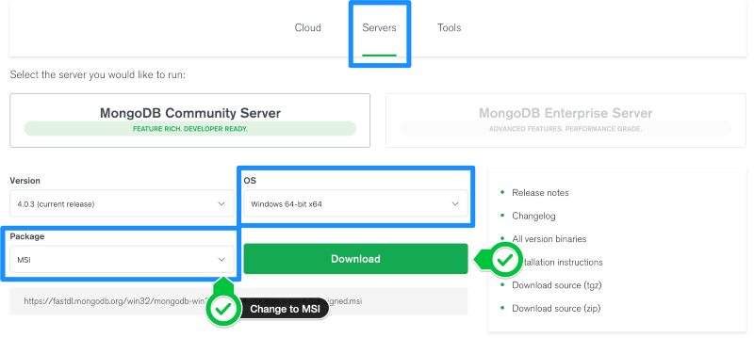

### Step 2 — Install MongoDB with the Installation Wizard

A. Make sure you are logged in as a user with Admin privileges. Then navigate to your downloads folder and double click on the .msi package you just downloaded. This will launch the installation wizard.

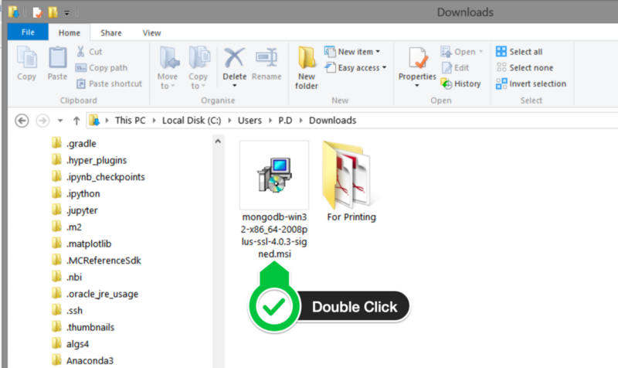

B. Click Next to start installation.

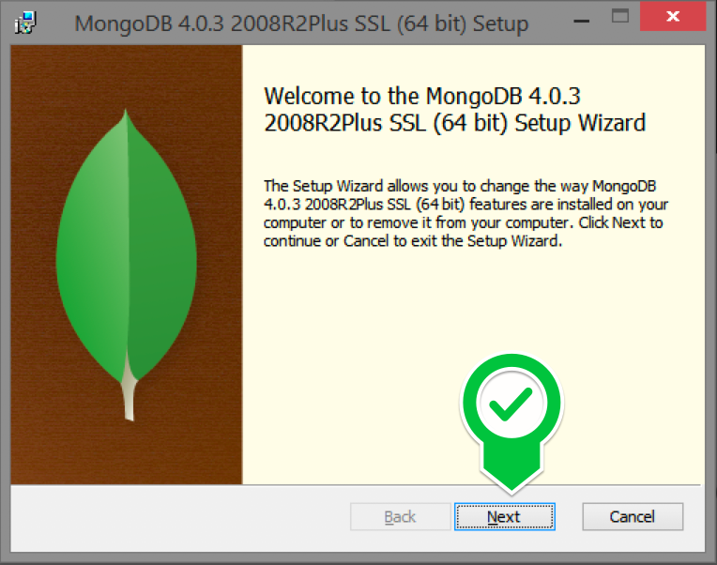

C. Accept the licence agreement then click Next.

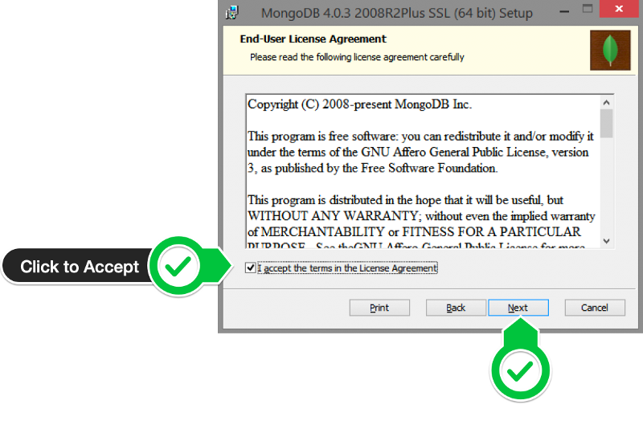

D. Select the Complete setup.

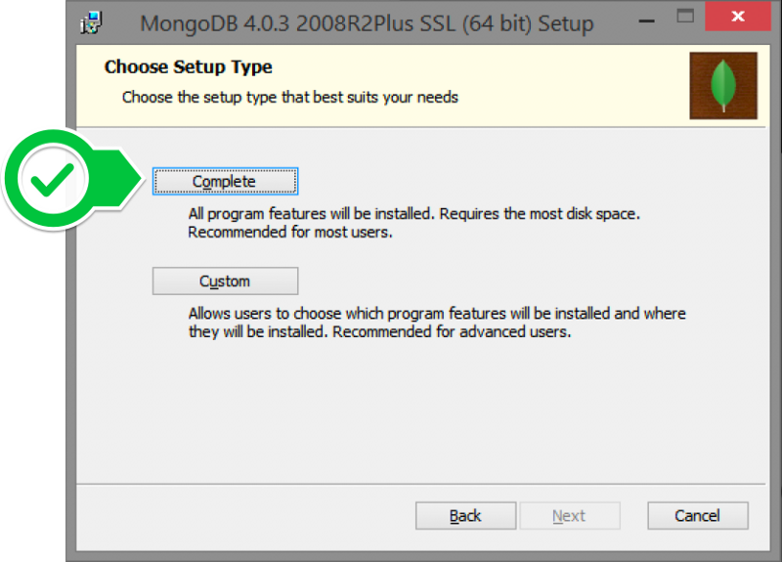

E. Select “Run service as Network Service user” and make a note of the data directory, we’ll need this later.

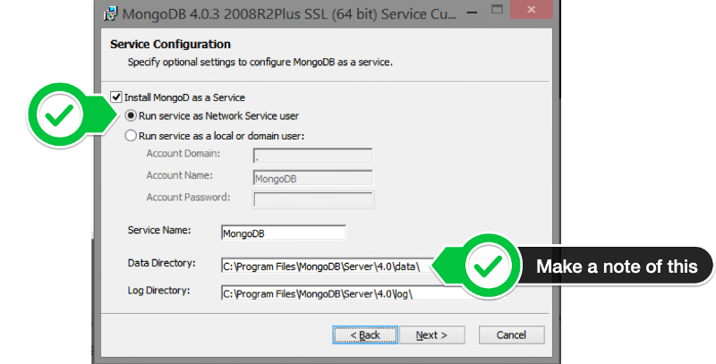

F. We won’t need Mongo Compass, so deselect it and click Next.

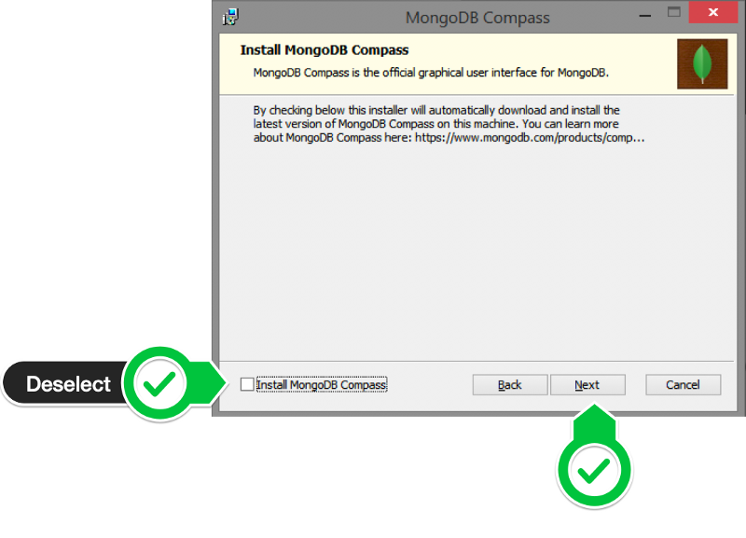

G. Click Install to begin installation.

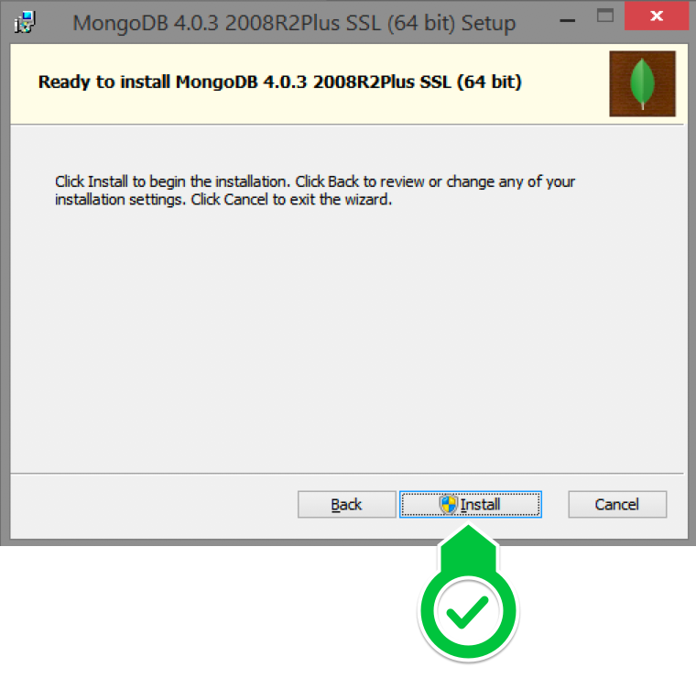

H. Hit Finish to complete installation.

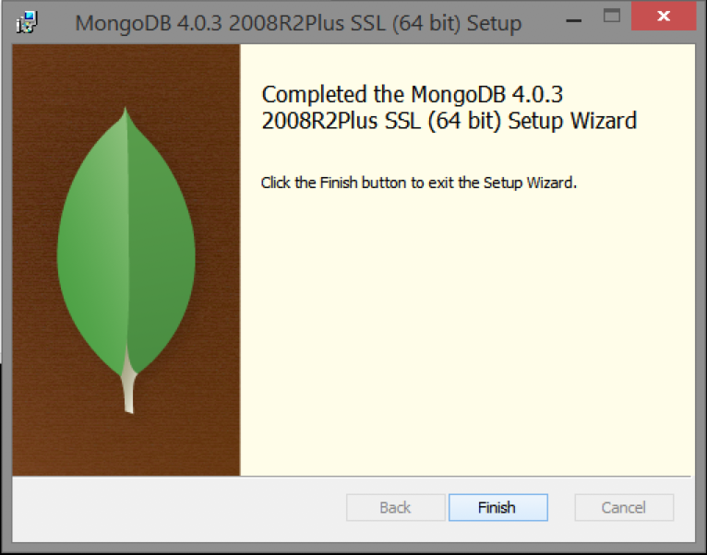

### Step 3— Create the Data Folders to Store our Databases

A. Navigate to the **C Drive** on your computer using Explorer and create a new folder called **data** here.

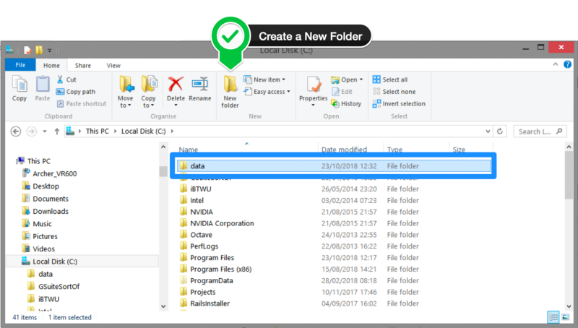

B. Inside the **data** folder you just created, create another folder called **db**.

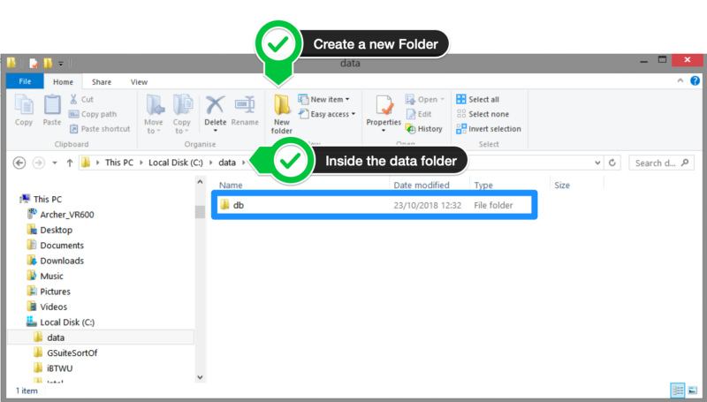

### Step 4 — Setup Alias Shortcuts for Mongo and Mongod

Once installation is complete, we’ll need to set up MongoDB on the local system.

A. Open up your Hyper terminal running Git Bash.

B. Change directory to your home directory with the following command:

cd ~

C. Here, we’re going to create a file called .bash_profile using the following command:

touch .bash_profile

D. Open the newly created .bash_profile with vim using the following command:

vim .bash_profile

E. In vim, hit the **I** key on the keyboard to enter insert mode.

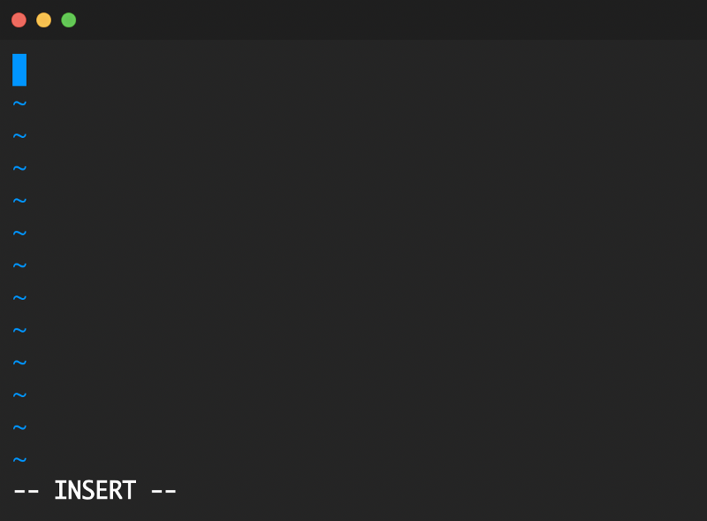

F. In your explorer go to C → Program Files → MongoDB → Server

Now you should see the version of your MongoDB.

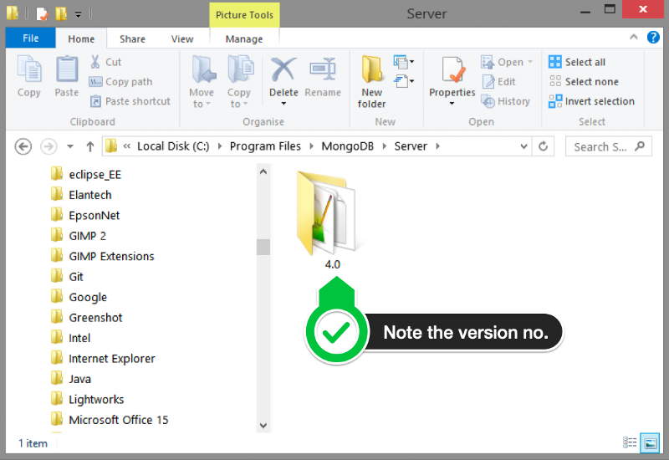

G. Paste in the following code into vim, make sure your replace the 4.0 with your version that you see in explorer

alias mongod="/c/Program\ files/MongoDB/Server/4.0/bin/mongod.exe"  
alias mongo="/c/Program\ Files/MongoDB/Server/4.0/bin/mongo.exe"

H. Hit the Escape key on your keyboard to exit the insert mode. Then type

:wq!

to save and exit Vim.

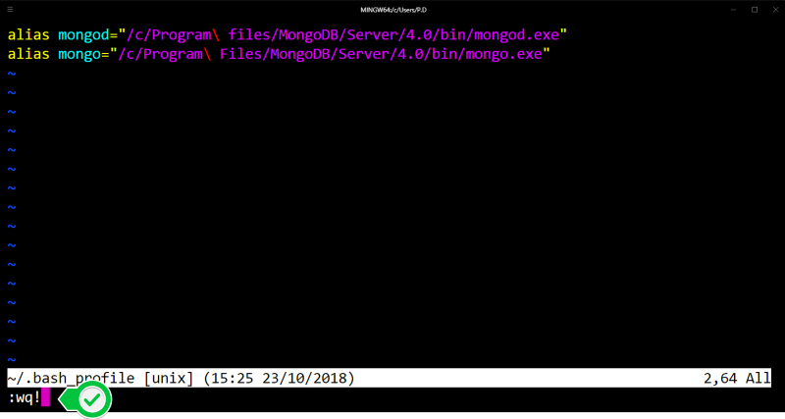

### Step 5 — Verify That Setup was Successful

A. Close down the current Hyper terminal and quit the application.

B. Re-launch Hyper.

C. Type the following commands into the Hyper terminal:

mongo --version

Once you’ve hit enter, you should see something like this:

# Project Requirements

## Packages in Angular

1. ngx-barcode:-

>npm install ngx-barcode

An angular component for Angular 4+ for creating 1-D barcodes based on [Lindell's JsBarcode](https://github.com/lindell/JsBarcode).

* + supports all barcode formats provided by JsBarcode
* CODE128
* EAN
* CODE39
* ITF-14
* MSI
* Pharmacode
* Codabar



1. @ngx-pwa/local-storage:-

>npm i @ngx-pwa/local-storage

Angular does not provide a local storage module, and almost every app needs some local storage. There are 2 native JavaScript APIs available:

* [localStorage](https://developer.mozilla.org/en-US/docs/Web/API/Storage/LocalStorage)
* [IndexedDB](https://developer.mozilla.org/en-US/docs/Web/API/IndexedDB_API)

The localStorage API is simple to use but synchronous, so if you use it too often, your app will soon begin to freeze.

1. json-stringify:-

>npm i json-stringify

A common use of JSON is to exchange data to/from a web server

When sending data to a web server, the data has to be a string.

Convert a JavaScript object into a string with JSON.stringify().

1. rxjs:-

>npm install rxjs

Reactive Extensions Library for JavaScript. This is a rewrite of [Reactive-Extensions/RxJS](https://github.com/Reactive-Extensions/RxJS) and is the latest production-ready version of RxJS. This rewrite is meant to have better performance, better modularity, better debuggable call stacks, while staying mostly backwards compatible, with some breaking changes that reduce the API surface.

1. rxjs-compat:-

>npm install rxjs-compat

Reactive Extensions Library for JavaScript. This is a rewrite of [Reactive-Extensions/RxJS](https://github.com/Reactive-Extensions/RxJS) and is the latest production-ready version of RxJS. This rewrite is meant to have better performance, better modularity, better debuggable call stacks, while staying mostly backwards compatible, with some breaking changes that reduce the API surface.

1. http:-

> npm install http

Installing the module, the app will make requests to and receive responses from the [Http Client](https://angular.io/api/common/http/HttpClient) without knowing that the In-memory Web API is intercepting those requests, applying them to an in-memory data store, and returning simulated responses.

## Packages in Python

1. pymongo:-

>pip install pymongo

The PyMongo distribution contains tools for interacting with MongoDB database from Python. The bson package is an implementation of the [BSON format](http://bsonspec.org/) for Python. The pymongo package is a native Python driver for MongoDB. The gridfs package is a [gridfs](http://www.mongodb.org/display/DOCS/GridFS+Specification) implementation on top of pymongo.

1. Jsonify:-

>pip install jsonify

jsonify is a python script that takes a .csv file as input and outputs a file with the same data in .json format.

1. flask-jsonify:-

> pip install Flask-Jsonpify

Flask-Jsonpify is an extension to Flask’s core jsonify function, returning JSON-Padded responses when a callback is specified as request’s arguments. It’s usage and implementation is the same as flask.jsonify, differing only when a request has a callback specified in the request arguments, in which case the response body is JSON-Padded, or JSONP, using the callback.

1. responses:-

> pip install responses

1. flask_json:-
   * pip install flask_json

Flask-JSON is a simple extension that adds better JSON support to Flask application.

Features:

* Works on python 2.6, 2.7, 3.3+ and Flask 0.10+.
* More ways to generate JSON responses (comparing to plain Flask).
* Extended JSON encoding support.

# Practical Implementation

* + Login Page

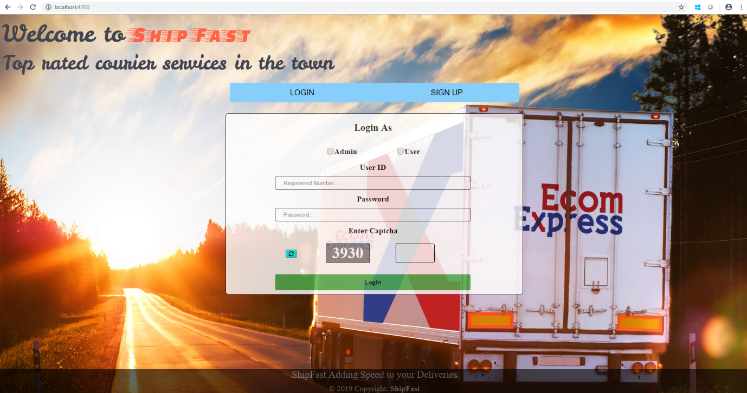

* + Signup Page

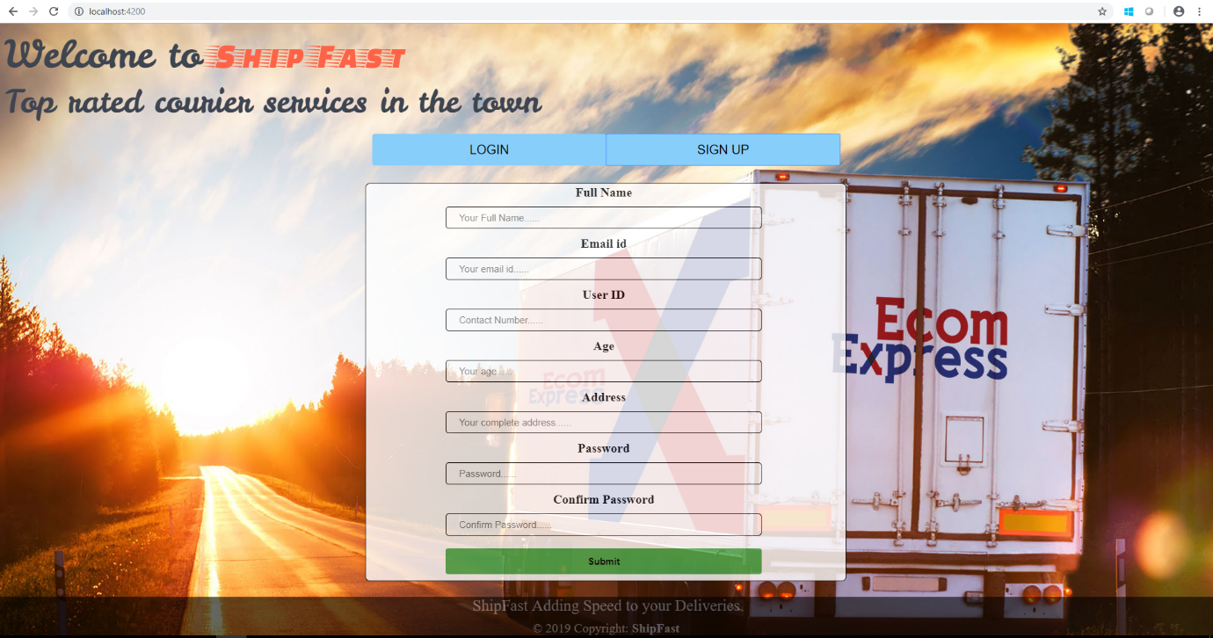

* + MongoDB

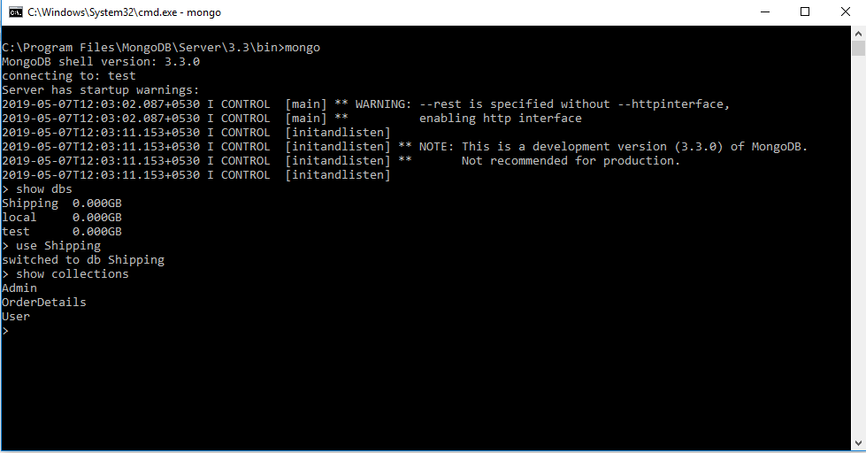

* + Server Status

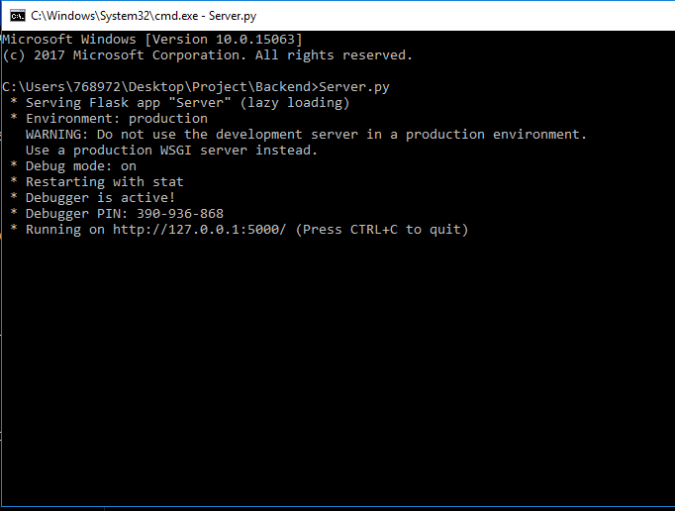

* + Localhost

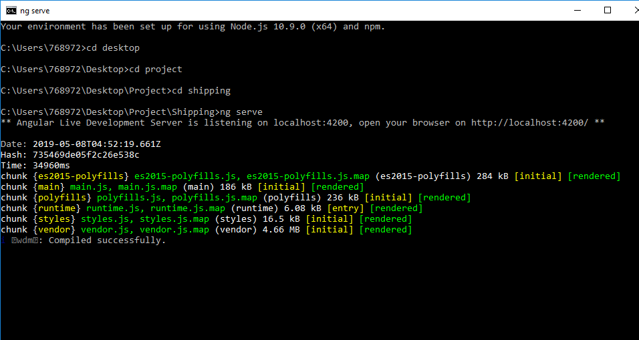

* + Admin Home

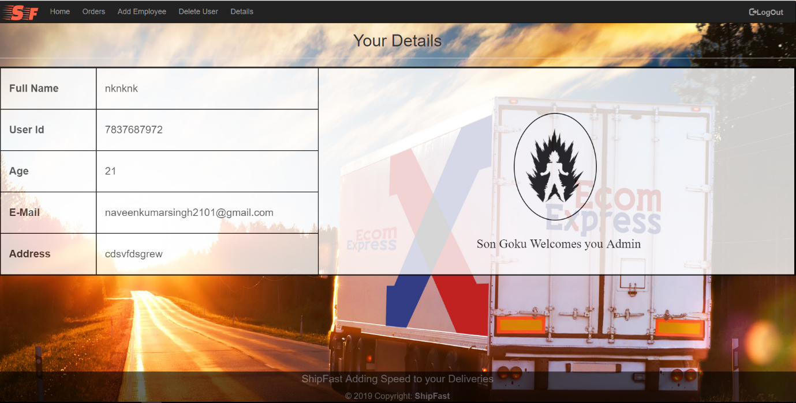

* + Order Approval

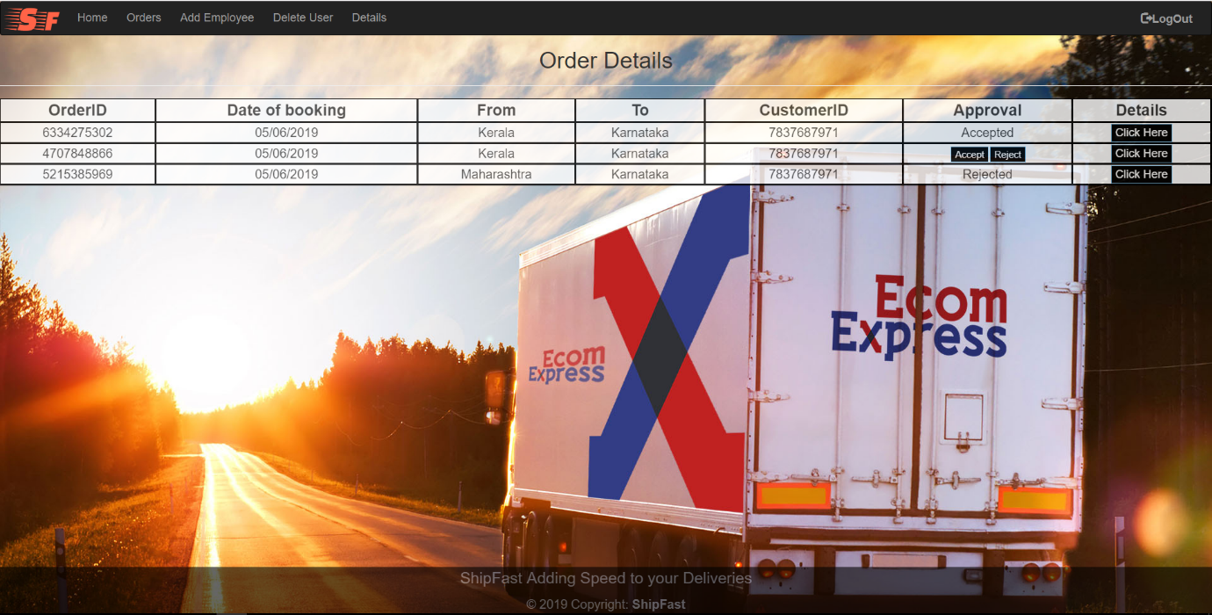

* + Order Detail

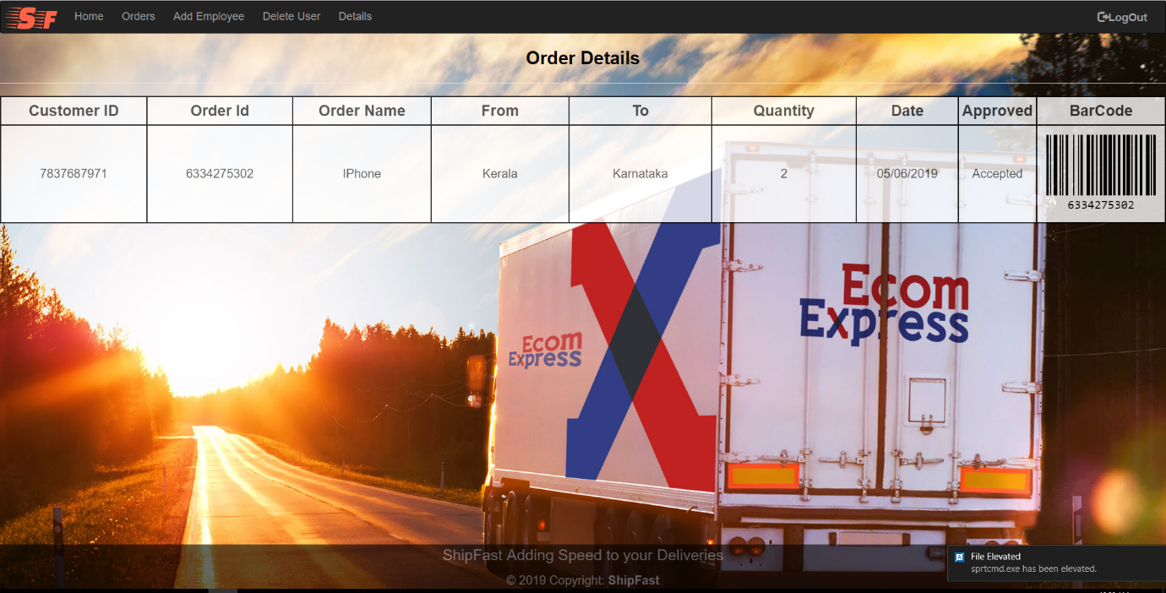

* + Add Employee

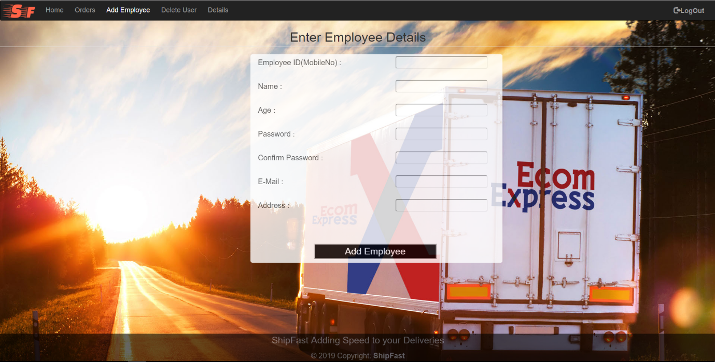

* + Delete User

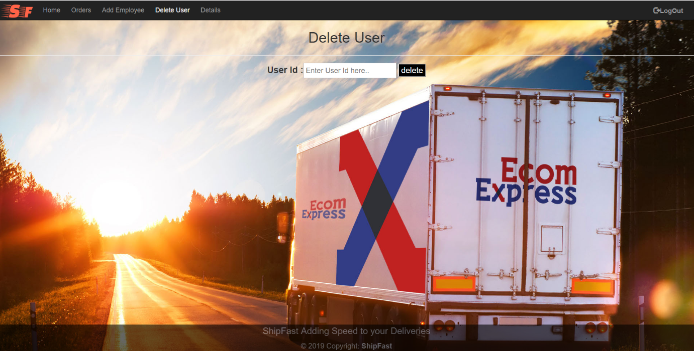

* + Detail Check

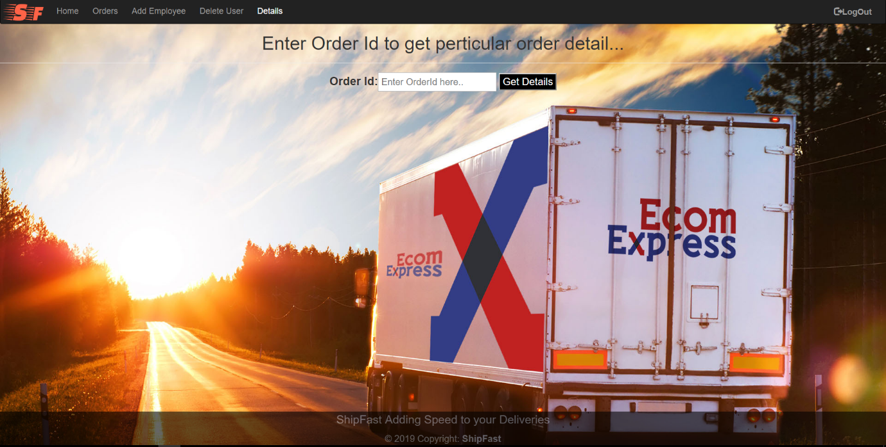

* + AdminDB

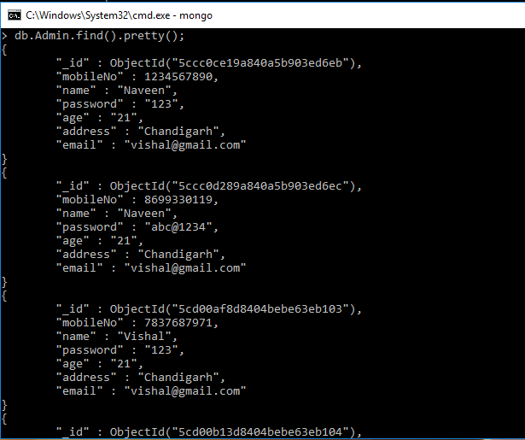

* + User Home

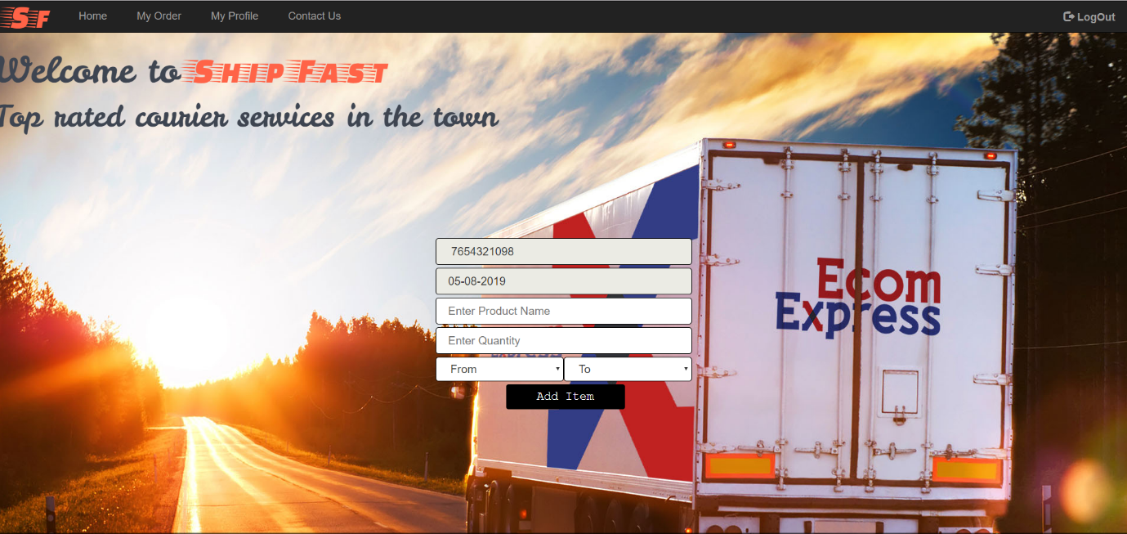

* + User Orders

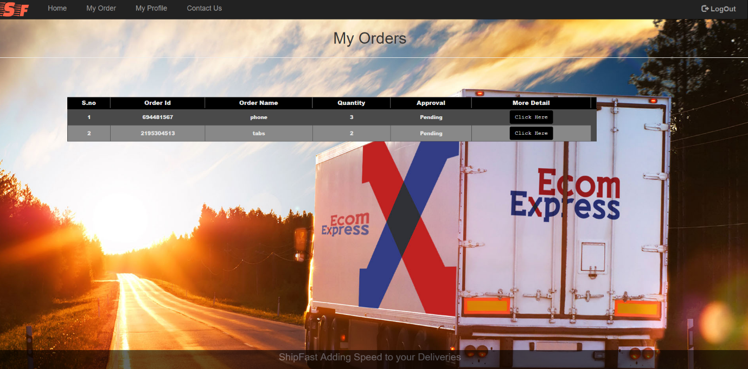

* + Order Approval Status

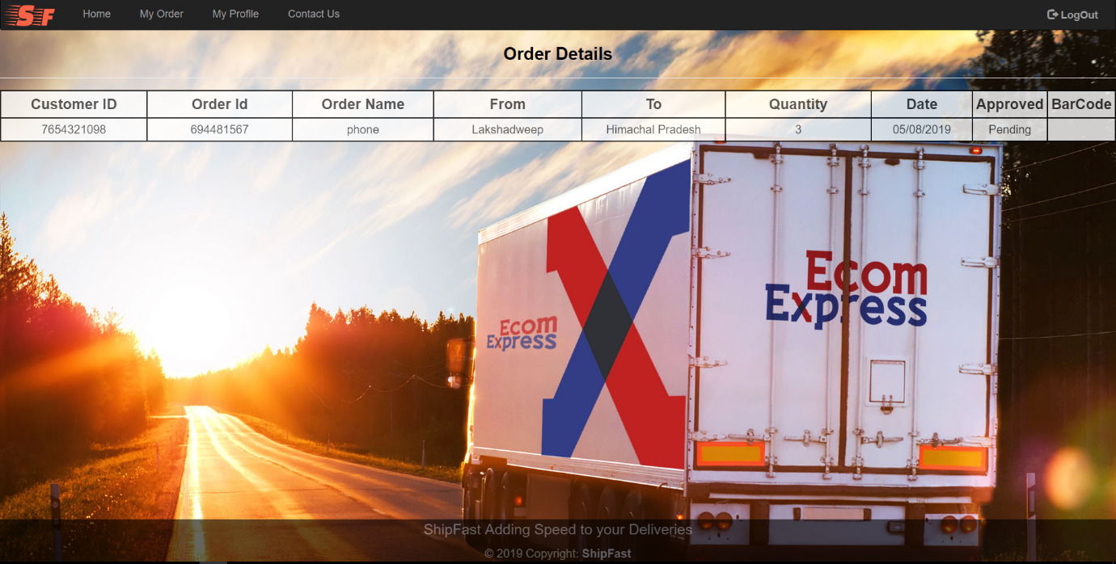

* + User Profile

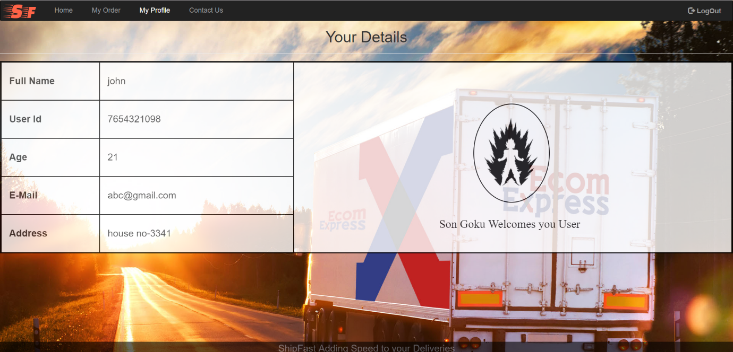

* + User contactus Page

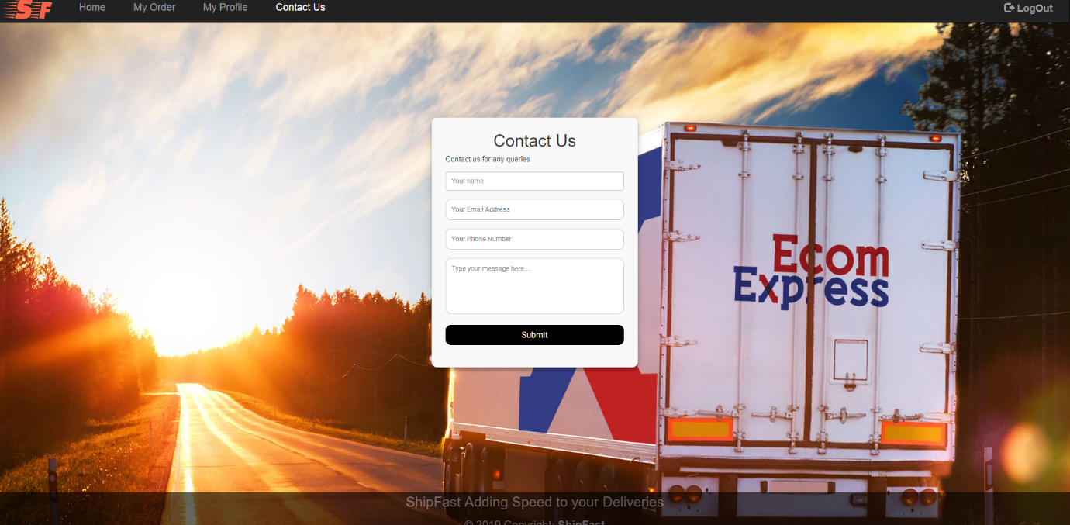

* + User DB

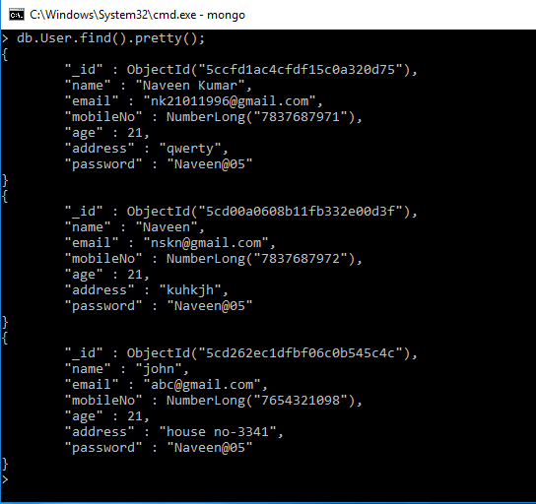

* + Order Details DB

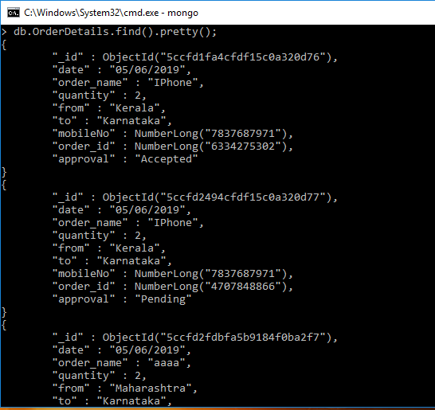

* + Server Working Status

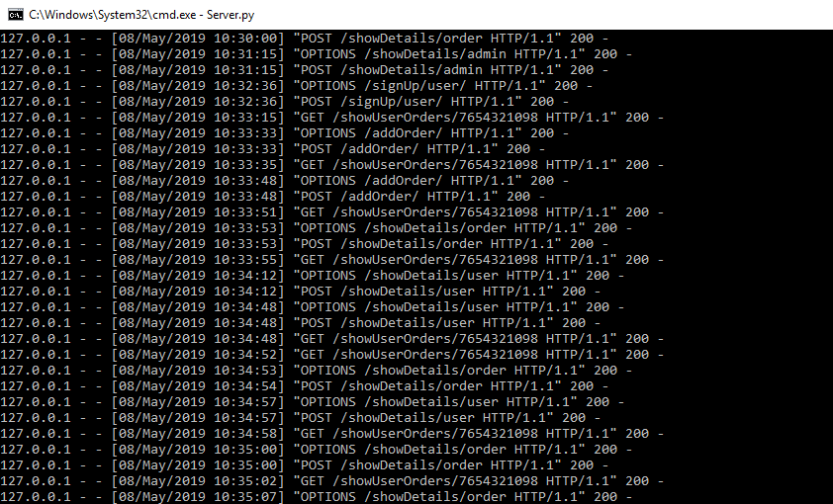

# Annexure

<https://angular.io/>

<https://en.wikipedia.org/>

<https://www.mongodb.com/>

<https://www.python.org/>

# Terms & Conditions

Interns shall be solely responsible for all its acts and omissions under this program. Interns will comply at all times with all applicable laws. Interns shall not use Cognizant’s name, logo and trademark in any promotional materials or other communications with third parties without the prior written consent of Cognizant. Any materials used by interns in relation to program will not infringe the copyrights, trademarks, patents, trade secrets or other intellectual property rights, privacy or similar rights of any person or entity. Interns agrees not to post, draw, make, display any content that is threatening, libelous, obscene, defamatory, abusive, pornographic, or advocates/encourages any conduct that could constitute a criminal offence or give rise to any civil liability. Cognizant its associates’ personal details including but not limited to name, address, contact number shall not be shared or forwarded to any third party, without prior written consent of Cognizant, its associates. All intellectual property provided by Cognizant as part of program shall be owned exclusively by Cognizant. Intern shall indemnify, defend and indemnify Cognizant its associates, officers, directors from and against any claims, demands, loss, damage, liability, causes of action, judgments, or costs and expenses of every nature (including attorney’s fees and expenses) incurred by Cognizant based on any claim that any breach of terms and conditions of this program.

# Change Log

Please note that this table needs to be maintained even if a Configuration Management tool is used.

|  |  |  |  |  |
| --- | --- | --- | --- | --- |
| Version Number | Changes made | | | |
| V1.0 |  | | | |
| V1.1 | *<If the change details are not explicitly documented in the table below, reference should be provided here>* | | | |
| Page no | Changed by | Effective date | Changes effected |
|  |  |  |  |
|  |  |  |  |
|  |  |  |  |
|  |  |  |  |
| V1.2 | *<If the change details are not explicitly documented in the table below, reference should be provided here>* | | | |
| Page no | Changed by | Effective date | Changes effected |
|  |  |  |  |
|  |  |  |  |
|  |  |  |  |